what ARE

lambda function?

and

creating a

lambda function

triggered by s3 in aws

What are

Lambda Functions?

**Lambda functions, also known as anonymous functions, are small, single-expression functions that don't require a formal name. They are particularly useful for short-lived operations where defining a full-fledged function would be overkill. Lambda functions are commonly used in functional programming paradigms and are supported by many programming languages, including Python, JavaScript, and Java.**

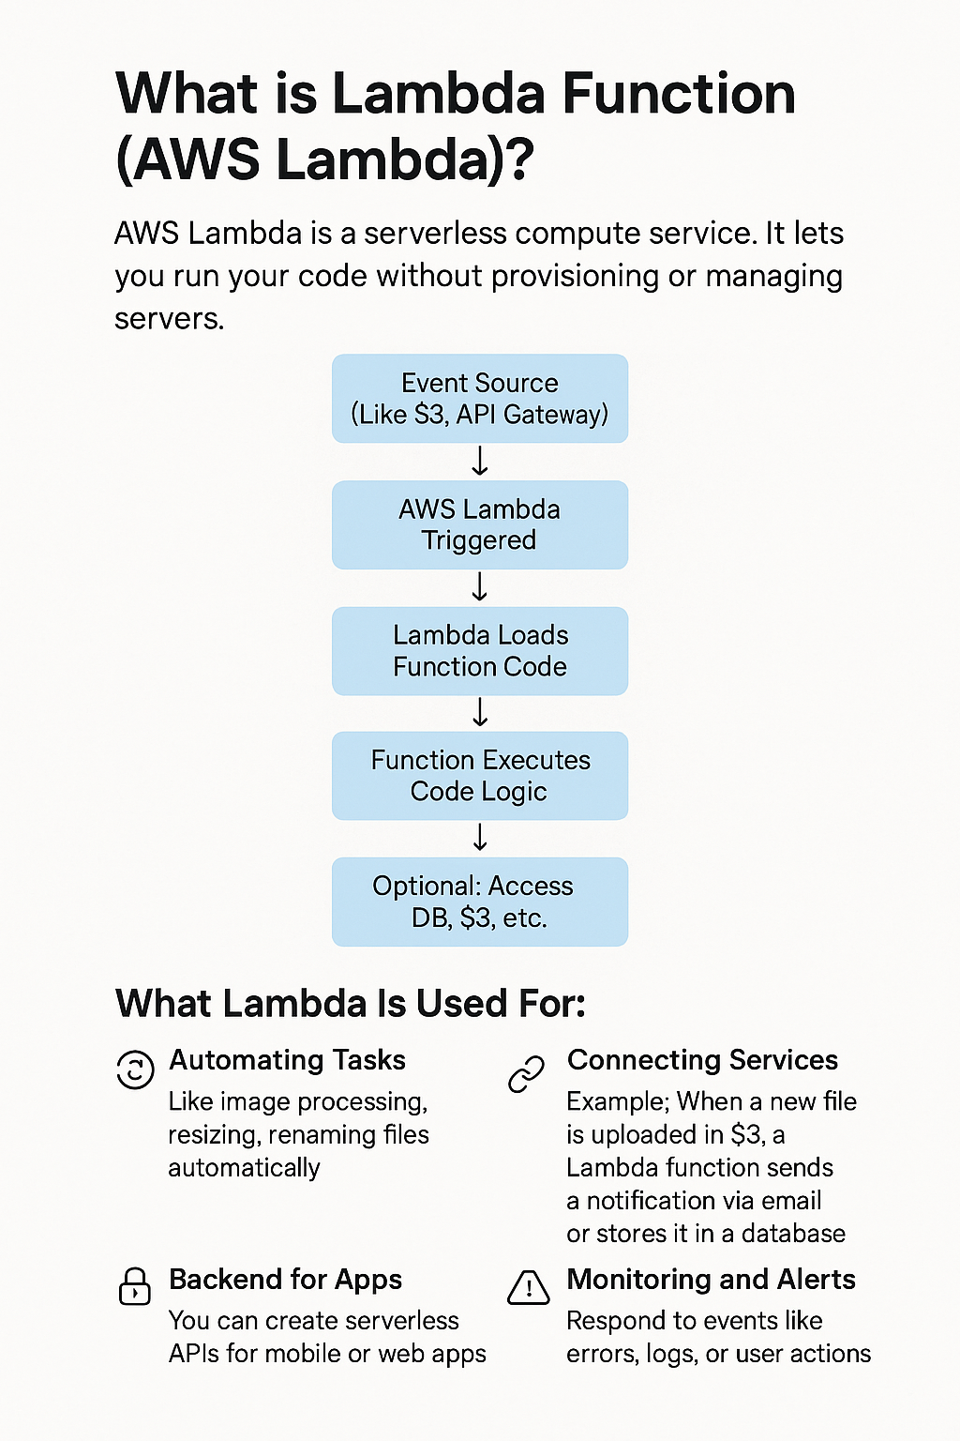

# creating a Lambda Function Triggered by S3 in AWS

**>STEP 1: Sign in to AWS Management Console:**

1. Click on the **Open Console** button, and you will get redirected to AWS Console in a new browser tab.  
2. On the AWS sign-in page,  
Leave the Account ID as it is {default- the 12 digit Account ID present in the AWS Console.} It shouldn’t be changed.  
3. Enter **Username** and **Password** in the Lab Console to the **IAM Username and Password** in AWS Console and click on the **Sign in** button.  
4. Once Signed in to the AWS Management Console, switch the default AWS Region as **US East (N. Virginia) us-east-1.**

**>STEP 2: Create an S3 Bucket**

1. In this task, we will create S3 bucket.   
2. Navigate to the **Services**  tab at the top. Open **S3**  service from the **Storage**  section.   
3. On the S3 dashboard, click on **Create bucket**button.  
4. Provide a unique bucket name  
 Note:  S3 bucket names are globally unique, choose a name that is available.

5. Region: Select **US East (N. Virginia) us-east-1 as region**  
6. Object ownership: Set object ownership to ‘**ACLs disabled (recommended)’**.

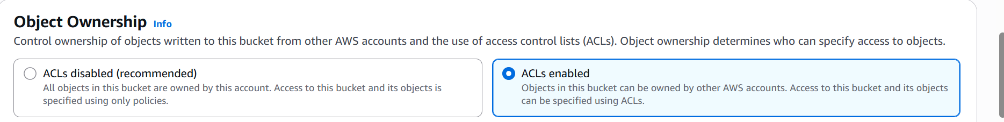

7.After that, uncheck the option to block all public access box and accept the acknowledge box

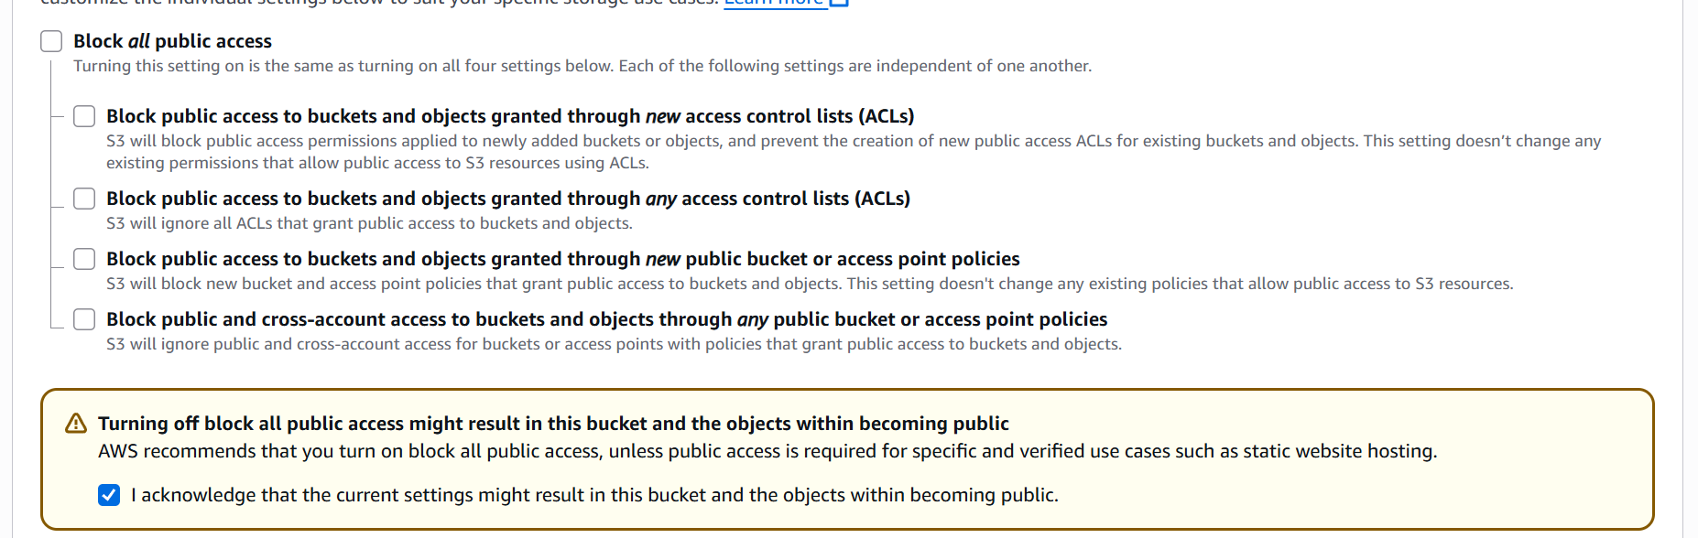

8. Click on the **Create bucket** button

**>STEP 3: Create a Lambda Function**

1. Go to the AWS Lambda console.   
2. Click "**Create function**".   
3. Choose "**Author from scratch**".  
4. Give your function a name (e.g., demofunction).  
  
5. Choose a **runtime** (like Python 3.x or Node.js).

6. For permissions, choose "Create a new role with basic Lambda permissions".  
7. Once done, Click "Create function".

**>STEP 4: Add S3 Trigger**

1. Inside the lambda section’s dashboard , scroll to **Function overview** section, click "**Add trigger**".

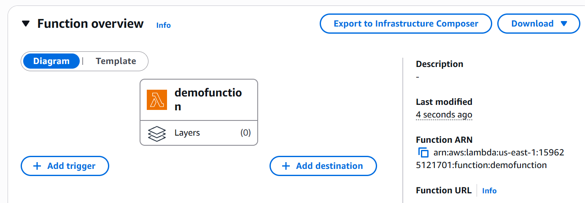

1. **Select "S3" as the trigger source**.

1. Choose the  **S3 bucket you made earlier.**

4. Set the event type to “All object create event”.

1. Click "Add".

**>STEP 5: Add Code to Lambda Function**

Example (Python):

import json

def lambda_handler(event, context):

    # TODO implement

    return {

        'statusCode': 200,

        'body': json.dumps('Hello from Lambda!')

    }

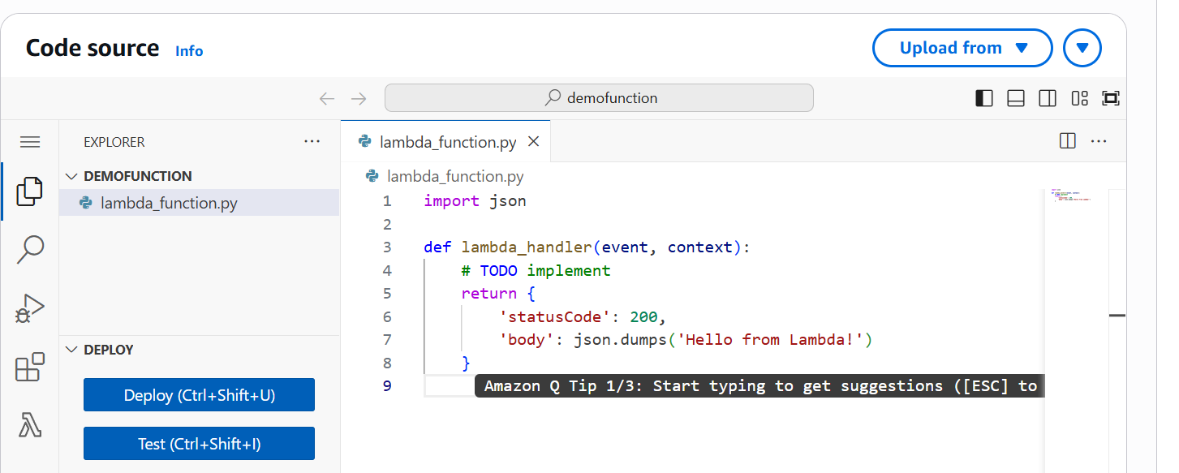

**Click "Deploy"** after updating the function code

**>STEP 6: Test the Setup**

Upload a file to the S3 bucket to trigger the Lambda Function

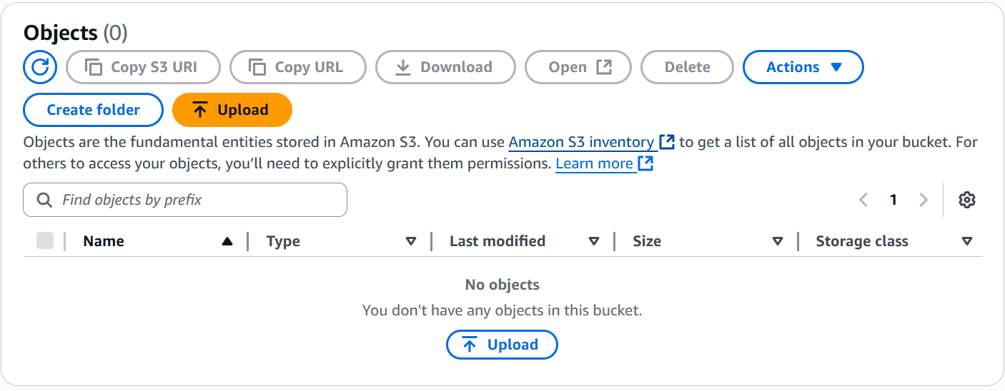

**Method 1.** (A) Go to the Lambda function’s "Monitor" tab and open CloudWatch Logs.

(B) Check the logs to verify if the function was triggered.

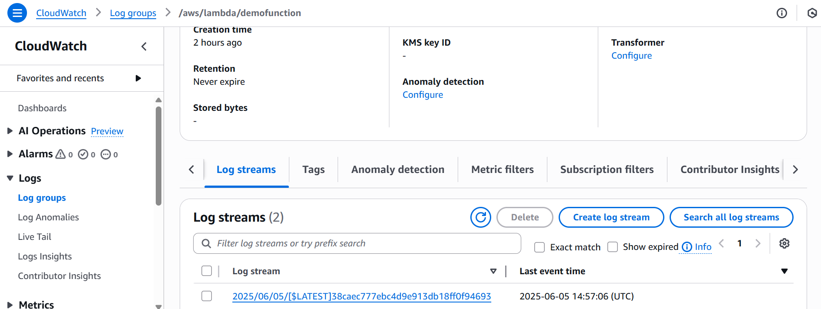

**Method 2:** Use Amazon CloudWatch Metrics

In CloudWatch > Metrics, navigate to: Lambda > By Function Name

Select your function to see the number of invocations and errors.

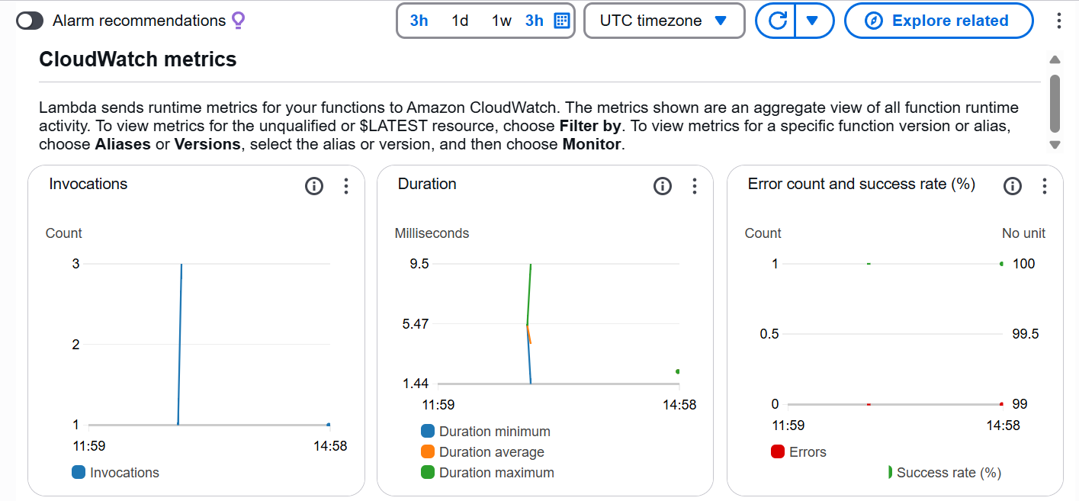

-[Note on Permissions]

1. If trigger doesn’t work , check to the IAM console.

2. Go to IAM console ,Locate the Lambda execution role and attach the "AmazonS3ReadOnlyAccess" policy or a custom policy with appropriate S3 permissions.

THANK YOU

#### BY- ISHMEET KAUR

BCA 2ND YEAR